# RL Agent Playground Output

## MountainCar - Random Agent

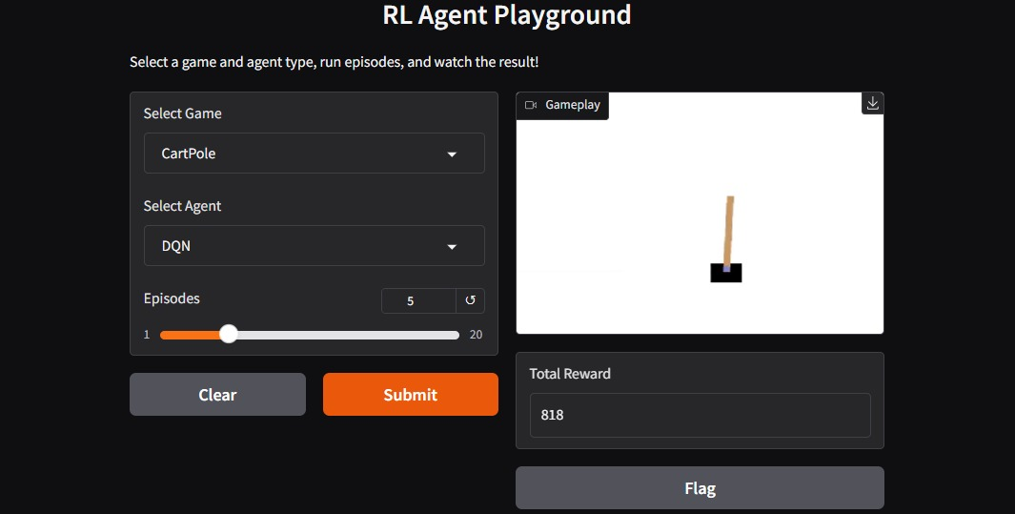

## MountainCar - DQN Agent

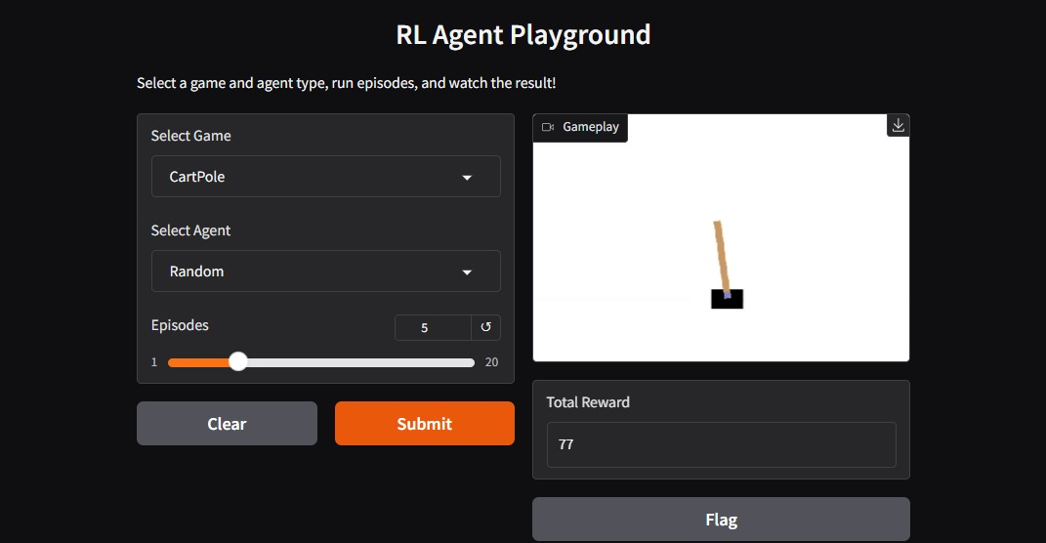

## CartPole - Random Agent

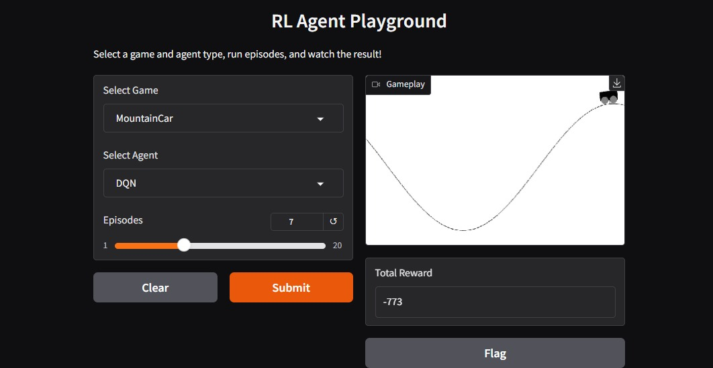

## CartPole - DQN Agent

